VIETNAM NATIONAL UNIVERSITY, HANOI
CENTER FOR APPLIED INFORMATION TECHONOLOGY

GUIDLINE FOR STUDENTS
ADMISSION SOFTWARE FOR INTERNATIONAL STUDENTS
TO VIETNAM NATIONAL UNIVERSITY, HANOI

Ha Noi - 2018

MỤC LỤC

1. Log-in 3
2. Create account and log-in 3
2.1. Create account 3
2.2. Active acount via Email 5
2.3. Log-in the sorfware 6
2.4. Reset password 6
3. Student site and registration page 7
3.1. Student site 7
3.2. Update student’s information 8
3.3. Apply to program 9
4. Undergraduate and Graduate application Form 10

- Log-in
Students click in to the link http://admissions-apply.vnu.edu.vn as picture below
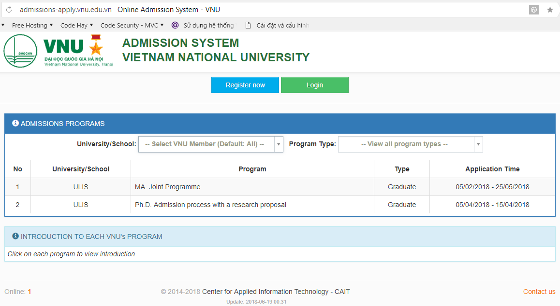
Picture 1. Home page
There are 3 parts in main display:
- Part 1: Students click [Register now] to register the account the first time log-in and use the account to [Login] the system.
- Part 2: The display expresses the recruiting information at VNU member universities/schools.
- Part 3: The display express guideline or describe of training programs, students move a computer mouse to the program and click in.
- Create account and log in
  - Create account
Students click on [Register now] – picture 1- and fill in their information to the form
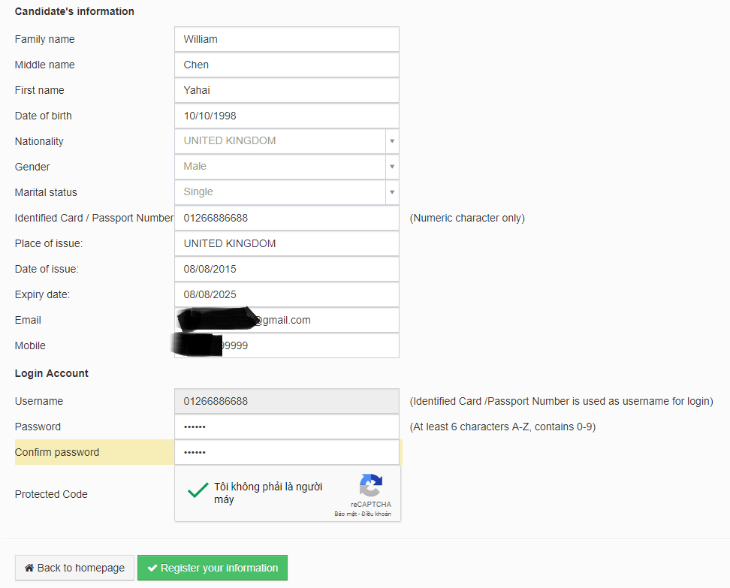
Picture 2: students create account

Note: Students insert correct his/her email to receive a link to active the account. After clicking the link sent to their email, their account may be active. Students use their Username and Password to login software

Students need to click in Protected Code to complete the register process. This code will protect student’s account.
Then, students click in [Register your information], the system will inform a message [you have registered successfully].

Picture 3. Created your account successfully

  - Active account via email
After creating successfully an account, students (as Picture 3), and students log-in to their email and click to the link to active the account.
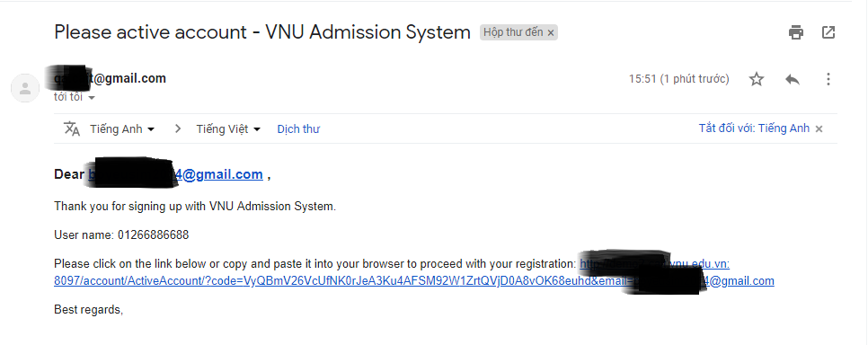
Picture 4. Click the link sent to Email to active the account
After click the link, the system will inform a message:
Picture 5. Active account successfully

  - Log-in the software
Students click to [Login] or [Return to login page] to go back to the admission page.
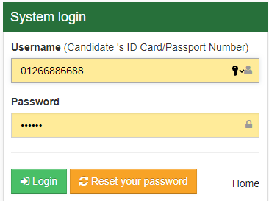
Picture 6. Log-in the system
Students use account, which is ID number or passport number, and password to log-in to the software.
  - Reset password
In case of forgetting password, students click [Reset your password] as Picture 6. Students fill their email in to the display of [Reset password] as Picture 7, new password will be sent to student’s email.
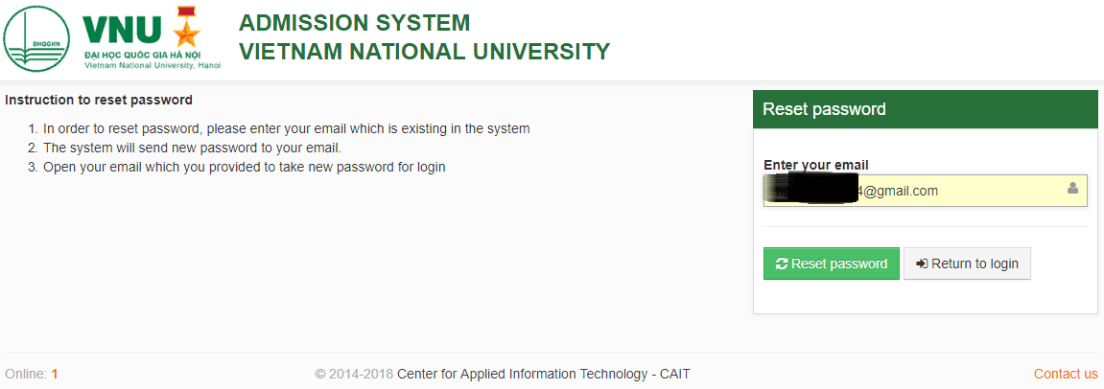
Picture 7. Reset Password

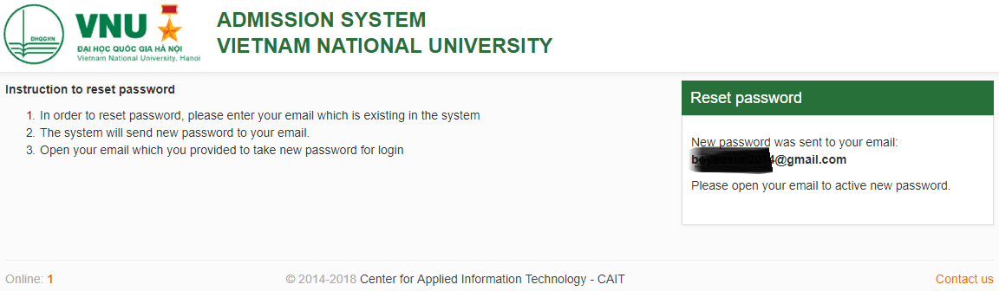
Picture 8. New password send to Email

- Student site and registration page
  - Student site
After log in, student will see the student site as picture below:
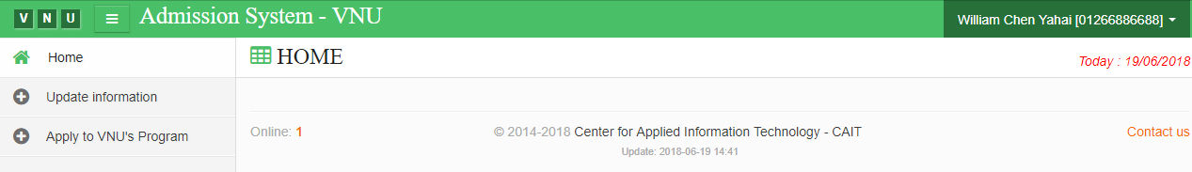
Picture 9. Student page

This page includes 4 main parts:
Part 1: Students can update their information in this page. Students can [Change password] or [Log out].
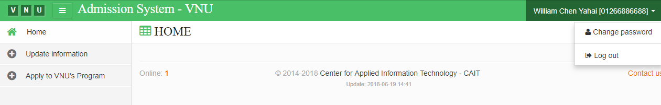
Picture 10. Log out
Part 2: Students can click [Home] to see announcements relating to their application from VNU member university/school to know whether their application is fully completed or need to add some information.

Part 3: Students can update their information by clicking to [Update information] up load student’s picture (compulsory) and other information (if have).
Part 4: All programs will appear on this display and students can click in to [Apply to VNU’s Program] to select the program.
  - Update student’s information
Students click in [Select picture] to insert picture to application form. Students can change the picture by clicking in [Delete picture] and select other one. The system will inform a message “Updated information successfully!” as picture below.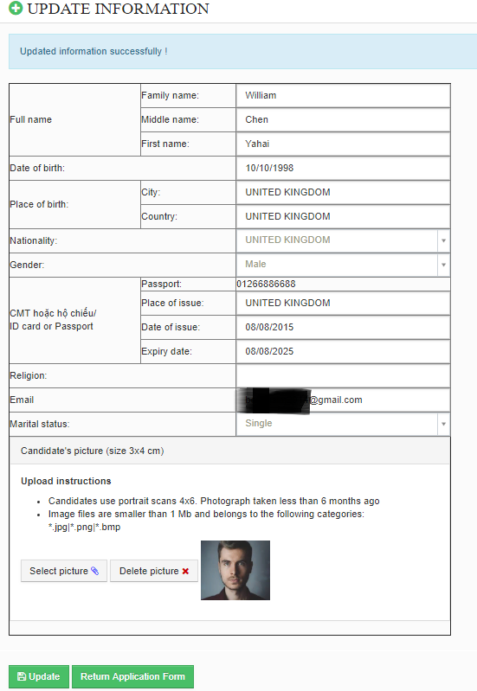
Picture11. Update information

  - Apply to program
Students click to [Apply to VNU’s Program] to apply for a program
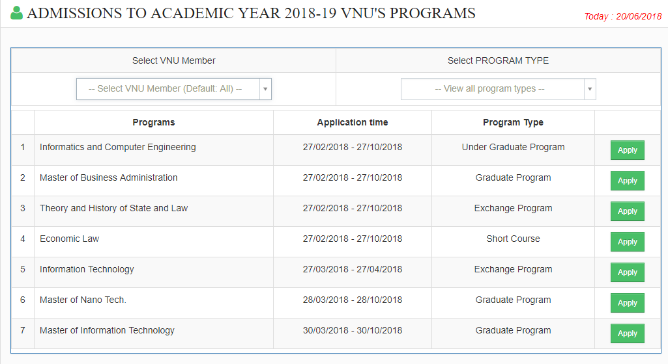
Picture 12. Selecting program screen

This screen includes 2 parts:
Part 1: Students select VNU member university/school and the preferable programs
Part 2: The display appears program’s information, time line and [Apply] function. Each kind of program (undergraduate and graduate program, exchange program and short-course program) has specific forms.
- Exchange Student application Form

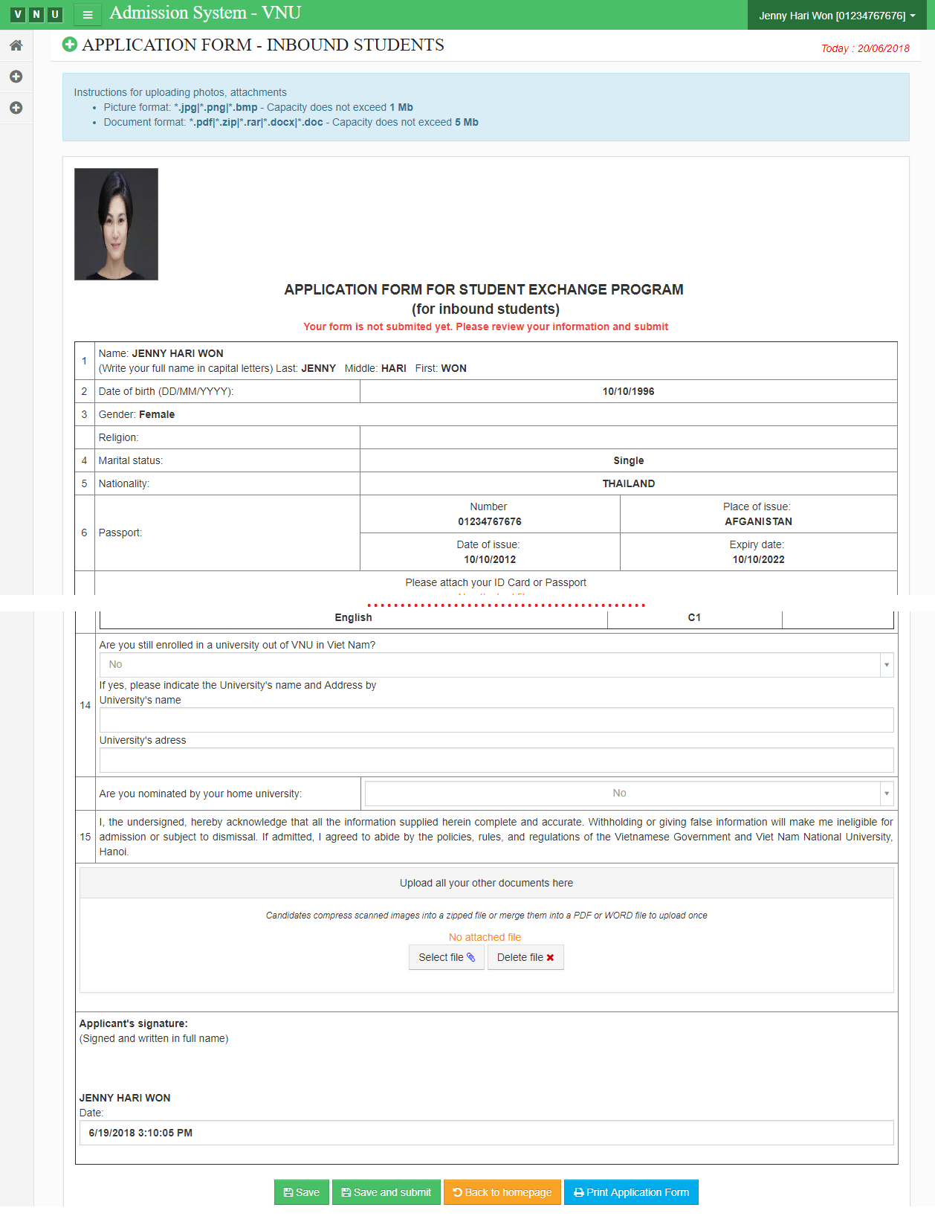
Picture 13. Admission form for Exchange Student Program
Students have to complete the registration form and attach the requirement document.
Students have 3 buttons at the end of the page:
- [Save]: Save the information, attach file any time. All files won't submit to the coordinator.
- [Save and submit]: After finishing the application form and submit, the coordinator can see the subscription content.
- [Print Application Form]: Students can print the form which you have finished.
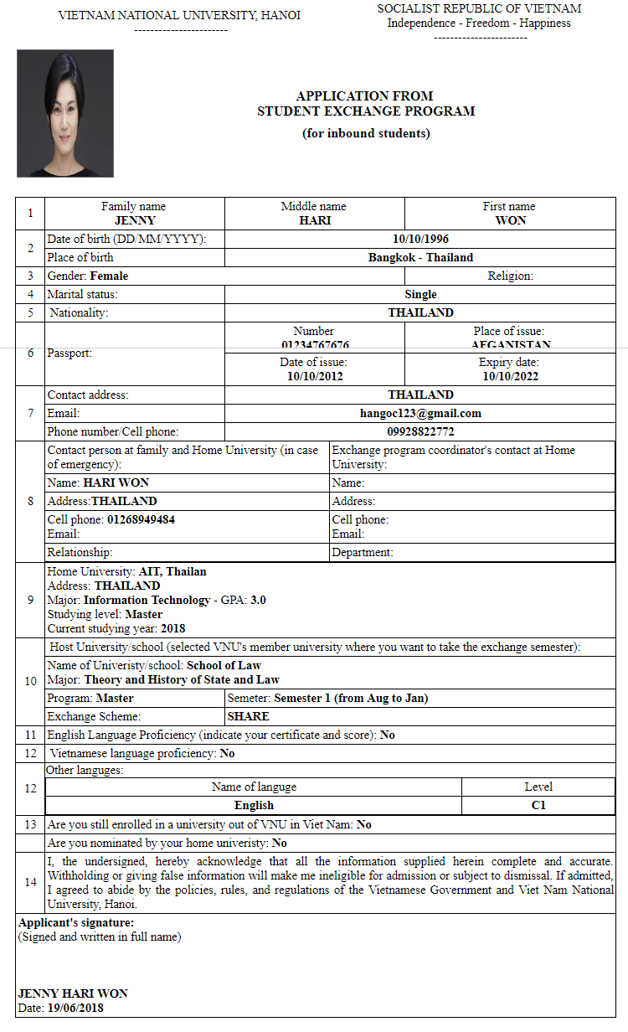
Picture 14. Exchange Student Program- printing form

